badminton
Scoring System
- A match consists of the best of 3 games of 21 points.
- Every time there is a serve – there is a point scored.
- The side winning a rally adds a point to its score.
- At 20 all, the side which gains a 2 point lead first, wins that game.
- At 29 all, the side scoring the 30th point, wins that game.
- The side winning a game serves first in the next game.

Badminton is played indoors
Some of you may be familiar with playing badminton on a beach, or in the garden. This is fine when you’re playing it as a casual game, but it doesn’t work when you start to get competitive.
The shuttle is blown off course by even the slightest breath of wind. That’s why competitive badminton is always played indoors.

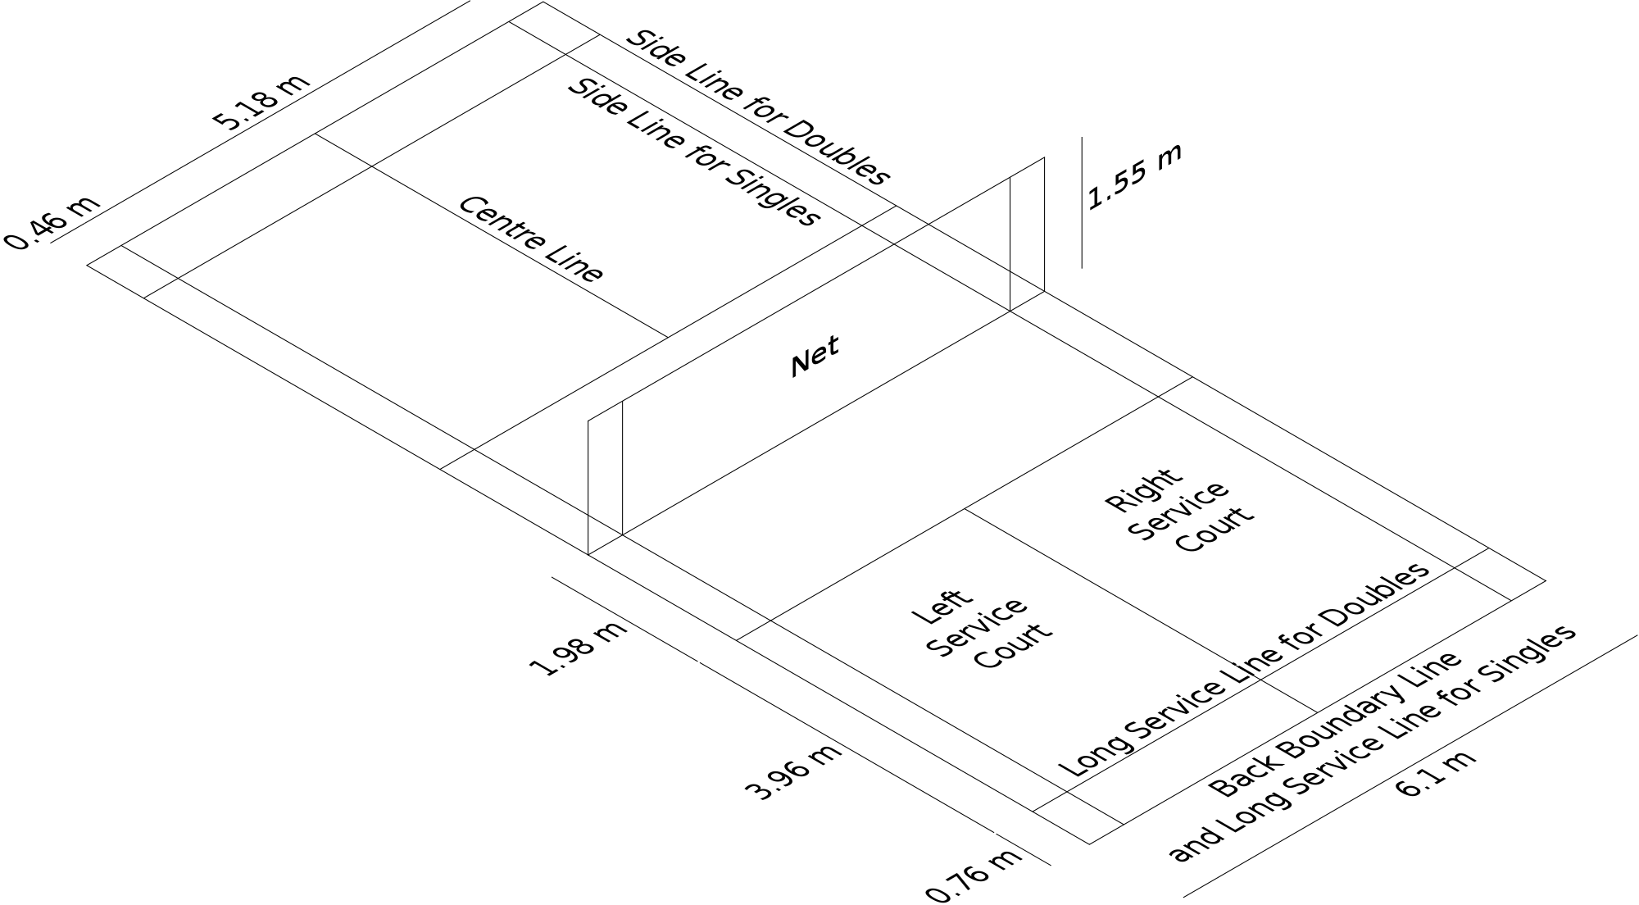

Course of action / Explanation | Score | Service from Service Court | Server & Receiver | Winner of the rally

 | Love All | Right Service Court. Being the score of the serving side is even. | A serves to C A and C are the initial server and receiver. | A & B | 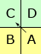
A & B win a point. A & B will change service courts. A serves again from Left service court. C & D will stay in the same service courts. | 1-0 | Left Service Court. Being the score of the serving side is odd | A serves to D | C & D
C & D win a point and also right to serve. Nobody will change their respective service courts. | 1-1 | Left Service Court. Being the score of the serving side is odd. | D serves to A. | A & B
A & B win a point and also right to serve. Nobody will change their respective service courts. | 2-1 | Right Service Court. Being the score of the serving side is even. | B serves to C | C & D
C & D win a point and also right to serve. Nobody will change their respective service courts. | 2-2 | Right Service Court. Being the score of the serving side is even. | C serves to B | C & D
C & D win a point. C & D will change service courts. C serves from Left service court. A & B will stay in the same service courts. | 3-2 | Left Service Court. Being the score of the serving side is odd. | C serves to A | A & B
A & B win a point and also right to serve. Nobody will change their respective service courts. | 3-3 | Left Service Court. Being the score of the serving side is odd. | A serves to C | A & B
A & B win a point. A & B will change service courts. A serves again from Right service court. C & D will stay in the same service courts. | 4-3 | Right Service Court. Being the score of the serving side is even. | A serves to D | C & D | 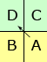
http://www.bwfbadminton.org/page.aspx?id=14914

History
The beginnings of badminton can be traced to the mid-1800s in British India, where it was created by British military officers stationed there.Early photographs show Englishmen adding a net to the traditional English game of battledore and shuttlecock. The sport is related to ball badminton, which originated in Tamil Nadu, and is similar toHanetsuki which originated in Japan. Being particularly popular in the British garrison town Poona (now Pune), the game also came to be known as Poona.Initially, balls of wool referred as ball badminton were preferred by the upper classes in windy or wet conditions, but ultimately the shuttlecock stuck. This game was taken by retired officers back to England where it developed and rules were set out.

Health Benefits of Playing Badminton

In fact it has been found that playing badminton till you get an increase in heart rate or mild breathlessness regularly in middle age lowers the risk of death by about 23% in the subsequent 20 years and improves longevity by at least 2 years. The optimal health benefits are achieved by playing badminton for at least 30 minutes a day after adequate warm up.
The main health benefit is reduction of bad cholesterol and increase in good cholesterol with regular badminton play. In our body, total cholesterol, triglycerides, low-density lipoproteins (LDL) and very low density lipoproteins (VLDL) are bad cholesterols and high-density lipoprotein (HDL) is the only good cholesterol.
Playing badminton regularly increases the levels of HDL good cholesterol while decreasing the levels of bad cholesterols. As bad cholesterols decrease the size of blood vessels promoting heart attacks and strokes, reduction in their levels translates into multiple health benefits for the individual.
Playing regular badminton conditions the body so that the basal heart rate drops a few beats per minute and blood pressure is reduced.Both these effects are helpful in hypertensive individuals. It may help them to ward off their hypertension without medicines and even if they are needed, only fewer amounts are required.
Another particular health benefit of playing regular badminton is protection from heart disease, especially heart attacks. Playing badminton conditions and strengthens the heart muscle besides reducing hypertension and keeping blood vessels from clogging as we have seen earlier. Even people with pre-existing heart disease can benefit by playing badminton within their endurance levels under medical supervision and advise.
Regular indulgence in badminton helps overweight people to reduce their weight and attain optimal weight for their height and age. This effect is due to the excess calories burnt during playing badminton which prevents them from accumulating as fat and increasing the individual's weight.
Moreover, the existing fat deposits are also mobilized to produce energy while playing badminton. But for achieving optimal weight loss, it has to be combined with diet modification as well.
Osteoporosis is a troublesome problem especially in the elderly and women after menopause. It occurs because the bones loose their density due to complex interactions between the body hormones, bone forming and bone dissolving cells. Individuals with osteoporosis can easily sustain fractures because of reduced bone strength to withstand stress and injury.
Osteoporosis can be prevented or delayed by regularly playing badminton, as physical activity is one major factor that prevents osteoporosis, irrespective of the age and sex of the individual. Playing badminton promotes the activity of the bone forming cells and help in the assimilation of calcium in the bone matrix, thereby strengthening it.

Additional health benefit of playing regular badminton is reduced incidence of cancers like cancer of the large bowel and cancer of breast.
Finally, playing badminton keeps you feeling well, strong, motivated, enthusiastic and young. It helps to ward off depression, anxiety, stress and increase self-esteem. It also helps in enjoying a better sleep in the night, thereby minimizing the incidence of pre-existing illnesses getting aggravated due to lack of sleep.

Plan:

Monday:Teach them how to serve(single and double)and let them serve ten times, and teach some skill, where is the area we can play in single , then they can play what ever they want(with badminton)
Tuesday:I don`t know how to say it but just some basic action. (I will tell you tomorrow)
Wednesday:same
Thursday: play single for 21 points(once)and then change, after whole of us play with each other, they can play.
Friday:play double(three group)with other group, then play!

1hour 20nminutes
0~10play any sports(basketball)
10~15prepare net
15~25 teach
25~30 let them serve ten times
30~40 teach some skill

