Badminton Unit Handout
~April 30th-May 9th
History
The sport of Badminton has its origins in a children’s game called “Battledore” or “Shuttlecock” which started in the 16th century in Japan, China, India and Greece. “Poona”, as it was known in India, was taken back to England by British Army Officers stationed there in the 1860’s.
In 1873, the Duke of Beaufort held a lawn party at his country place, Badminton. Poona was introduced there and became very popular among British society’s elite. Thus, the game became known as “The Badminton Game”.
In 1877, the first set of Badminton rules was composed by the Bath Badminton Club whose authority was taken over in 1893 by the Badminton Federation of England.
The International Badminton Federation was formed in 1934 with 9 founding members; England, Ireland Scotland Wales, Denmark, Holland, Canada, New Zealand, and France. Now there are over 150 countries in the federation.

Badminton Game Overview
All rules apply to both single and double matches unless otherwise specified.

Scoring: A match consists of the best of 3 games of 21 points. Win by 2, up to 30 points.

Serving & Rallying
RULE OF THUMB – the order of server depends on the
If your score is even, you serve on the RIGHT side of the court
If your score is odd, you serve from the LEFT side of the court.

Singles: At the start of the game 0-0, the server serves from the right side of the court.
Doubles: The player on the right side serves

Singles: If the server wins a rally, they serve again from the alternate service court.
Doubles: If the serving side wins, they switch sides, but not servers. If the receivers win the rally, they get the serve.

Doubles: When you regain possession, you switch servers.

Vocabulary

Backhand Shot - stroke used to return the shuttles hit the left of a right-handed player or the right of a left-handed player

Clear - shot hit deep into the opponent’s court

Drop Shot - a quick shot hit softly very close to the opponent’s court

Forehand Shot – stroke used to hit the shuttle to the dominate hand of a player

Rally – exchange of shots that decides each point

Serve – stroke used to put the shuttle into play at the start of each rally
Smash – A hard, overhand hit that forces the shuttle sharply downwards into the opponent’s court

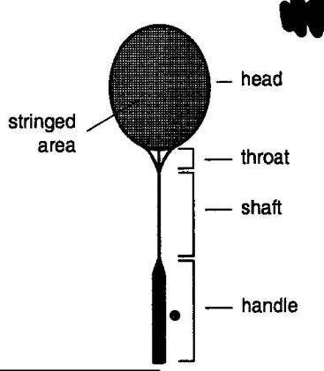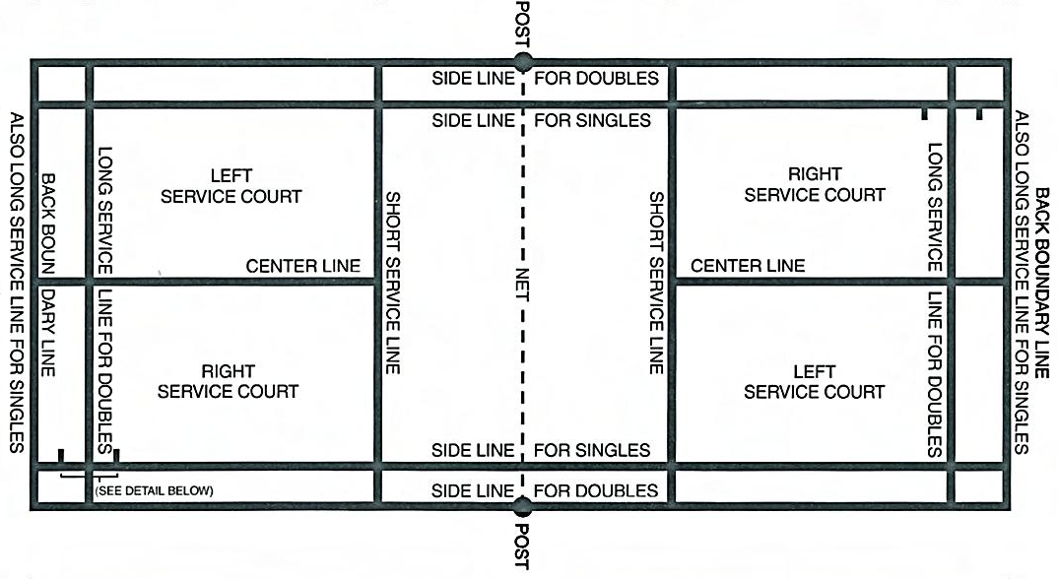

Boundary Lines
Singles: Service and game boundaries are the same – Far backline and inside side line.
Doubles: Service – Short backline and far side line.
During Games – Full court. Backline and far side line.

Note- If a shuttle lands on the outline during the play it is still considered IN.

Etiquette

The game of Badminton requires a high degree of manners and sportsmanship as there are most often no referees overlooking unofficial games.

Before serving, make sure your opponent is ready and call out the score.
Be honest. Players are responsible for making their own calls, whether the birdie is in or out.

Safety

Never walk through or behind a court during a rally.
Do not swing your racquet if you’re not playing on the court.

Bibliography

"Learn Badminion The Online Way!" History of Badminton. N.p., n.d. Web. 21 Apr. 2013.

"Badminton Equipment and History." Equipment and History. N.p., n.d. Web. 21 Apr. 2013.

"Badminton - The Court." Badminton - The Court. N.p., n.d. Web. 21 Apr. 2013.

