Soccer
Nicole and Danielle
Explanation
Basic Rules:
- There are 11 players on the field at once, including the goal keeper, with a minimum of 7. The positions are up to the coach.
- Each team is allowed to make three substitutions throughout the game, but once a player is substituted off (including for an injury) they’re not allowed back on.
- Regulation time for a match is 90 minutes, two 45 minute halves with a fifteen minute half time, but the referee can add ‘injury time’ to the end of each half, to compensate for lost time during the game.
- The clock doesn’t stop during the game.
- The teams switch sides after the half.
- The ball has to fully cross the goal line for it to count as a goal.
- Hand balls are when the ball touches your hand or arm.
  - Goalies can use their hands as long as they are inside their penalty box.
Offside:
- When an offensive player is closer to the net than the last two defensive players (including the goalie.)
- You can’t be offside on your own side of the field.
Beginning of the Game:
- The game starts with a coin toss. Whoever wins it decides to either pick their starting side or to have the ball first. The opposite team will start with the ball in the second half.
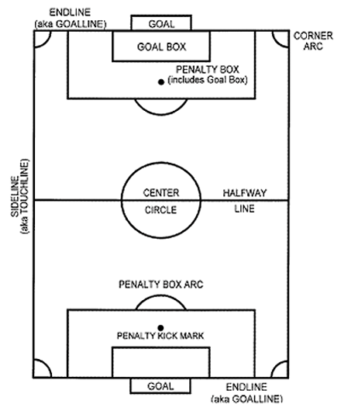
- The game and the half starts with a kick off, which is not like a face-off, with the two teams fighting for the ball. The team that starts with the ball is determined by the coin toss.
- Kick offs: The ball starts on the centre dot, and the first contact must be a forward movement and to another player.
Equipment:
- Shin guards
- Cleats
- Jersey with a visible number
Out of Play:
- When the ball is out of play, there are three ways of putting it back in: a corner kick, a goal kick, or a throw in.
- Goal kicks:
  - Used when the offensive team puts the ball out the end of the field
  - Someone from the defensive team kicks the ball from anywhere in the goal box.
  - Every other player has to stay outside of the penalty box.
- Corner kicks:
  - Used when the defensive team puts the ball out the end of the field
  - The ball is put in the corner and kicked in.
- Throw Ins:
  - Used when the ball goes out either of the sides.
  - The ball must go completely behind your head.
  - Your feet cannot come off the ground.
  - You can’t be offside on a throw in.

Infractions:
- Indirect free kick: the ball must make contact with another player before it can go in the net.
- Direct free kick: the ball doesn’t need to make contact with anyone else before it can go in the net. Players are allowed to create a “wall” or try to block the ball from a direct kick.
- Penalty kick: Similar to a direct free kick, except this is used when the infraction is committed inside the penalty box. All other players must be outside of the penalty box.
Offences:
- Overly aggressive or rude play (eg kicking, charging, pushing, spitting, holding) results in a direct free kick
  - If any of these happen inside the penalty box, a penalty kick is used instead.
- An indirect free kick is given:
  - Hand balls
  - If a goalie inside their penalty box:
    - holds the ball, releases it, and picks it up again before it touches another player
    - uses his hand after a teammate has deliberately passed it to him or thrown it into play (without making contact with another player)
Cards:
- Yellow cards: a ‘warning’ card. Given when a player commits a foul that the referee considers bad enough to have them thrown out of the game. 2 yellow cards results in an automatic red card. Yellow cards stay on your ‘record’ for future games.
- Red cards: a disqualification card. Can be awarded automatically, without any warning cards if the foul is bad enough.

History
Soccer is a sport that’s been around for a long time. The exact time and place it was created isn’t known, but early examples and variations of it have been found in China, Japan, Italy, Britain and Greece. The versions of soccer they played before though were rough, physical, and at times quite violent. Soccer was even banned in England in 1365 because of its violent nature. Modern soccer, with the rules we use now, started in England.
The first set of standardized rules created were the Cambridge Rules, made in 1815. These rules were still ‘optional’ though, with some of the schools and universities playing deciding to follow the rugby style of rules. The final ‘official’ rules were created in 1863 by the Football Association in England. They made a final version of the sport because of the many variations. The rules they made there are the same basic rules we use today.
The official name of the modern sport, the one designed by the Football Association in 1863, is Association Football. Other names used are football and soccer. Despite common opinion, the original proper name for the sport, used before 1863, was actually “soccer” rather than “football.” Football was the name the lower class used, while soccer was the name the upper class used.
FIFA, the Fédération Internationale de Football Association, was created in 1904. FIFA is an association that “governs” international soccer. They also organize the FIFA World Cup.
Soccer is the most popular sport in the world, with the most people playing it around the world. According to the FIFA rankings as of October 3, the top teams in the world are Spain, Germany, Portugal, and Argentina. Canada is ranked 61.

BIBLIOGRAPHY
The Laws of the Game. FIFA. Web. 18 Sep. 2012. <http://www.fifa.com/worldfootball/lawsofthegame/index.html>
Hiskey, Daven. The Origin of the Word “Soccer.” Today I Found Out, 23 June 2010. Web. 18 Sep. 2012. <http://www.todayifoundout.com/index.php/2010/06/the-origin-of-the-word- soccer/>
Jezek, Geno. Soccer History. History of Soccer! Web. 25 Sep. 2012. <http://www.historyofsoccer.info/>
FIFA/Coca-Cola World Ranking. FIFA, 3 Oct. 2012. Web. 4 Oct. 2012 <http://www.fifa.com/worldranking/rankingtable/index.html>

