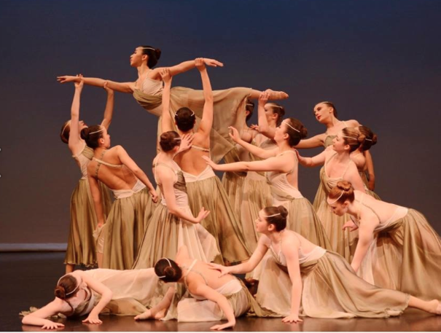
Dance

Types of Dance

- ____________
- Pointe
- Character
- _____________
- Lyrical
- ________________________
- ______________
- Breakdancing
- Street Jazz
- Acro
- ______________
- Interpretive
- Musical Theatre
- Stage
- Song & Dance
- Highland
- Salsa
- _________________
- Cabaret
- Bellydancing
- Flamenco
- Square Dance
- Zumba
- Etc.

History
Ballet dates back as early as the _________________, however, if you look as broad as the term “dancing”, it dates back to Biblical times. It is of more recent that dancing has turned into what it is today. There are more varieties and interpretations in this day an age, but these came about through adaptations and new additions to old repertoires. There are many famous ballets that are quite old, but are still classically done, as they are timeless. Some of the more famous ballets include ____________________, ___________________________, Cinderella, Don Quixote, The Sleeping Beauty, A Midsummer Nights Dream, ______________________, and ____________________________.

Strength
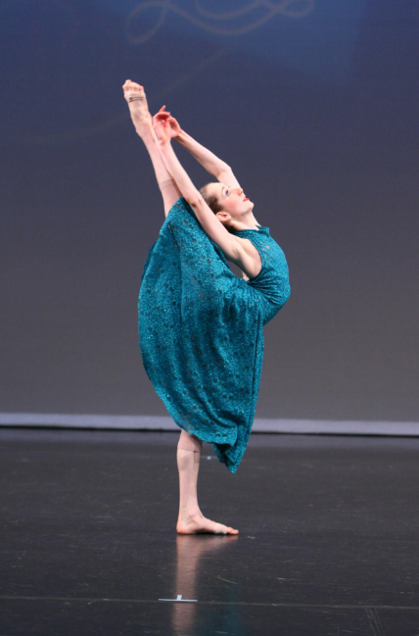
Have you ever watched So You Think You Can Dance? Have you ever gone to the Opera, the Ballet, or a musical? Dancers fly through the air, hold breath-taking positions and dance performances they have been training their whole lives for, while making it look as easy as walking down the street. A dancer’s job is not to make those watching see how impossibly hard their feats are, but instead, to make it look like this is the most natural and easiest accomplishment in the world.
In order to have the ______________ and ability to achieve any type of dance, conditioning is needed. One of the best ways to condition the body and gain the strength needed for most types of dance is through _____________. Ballet is considered to be the basis of dance. The ____________________, strength and ___________________ gained by those who study the art are beyond comparison. Ballet works different muscles than most other sports, which helps give ballet dancers their certain physique.
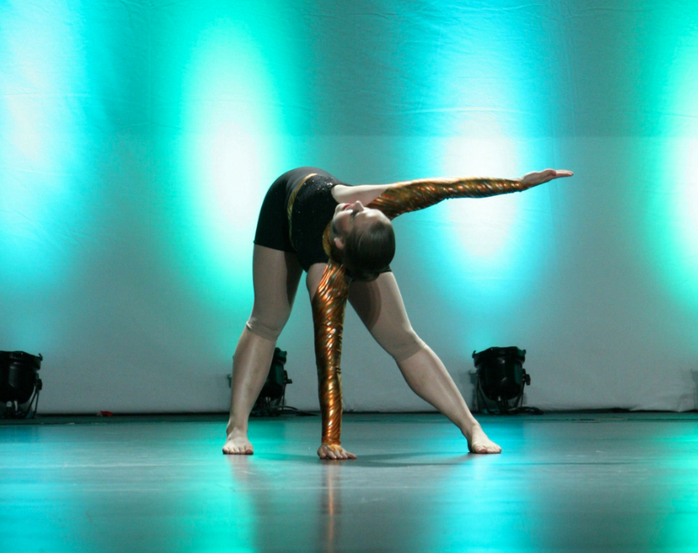
On top of ballet training, there are certain cardio, core and conditioning exercises or classes dancers take. Some different classes that help with strength are _____________ and __________________. Despite the incredible amount of strength dancers require, this is not only half the battle.

Flexibility
Another portion of the fight for a dancer’s success is their flexibility. Not only is flexibility important for being able to achieve some of the seemingly impossible positions for dancers, but a certain amount of it also helps prevent ______________ in every day life. Flexibility is constant work (for most people). When building up strength and working on flexibility, there is a fine balance to hold. Working on too much strength will hinder your flexibility growth, just as being as flexible as Gumby won’t be useful if you can’t control it. The flexibility dancers work towards is extreme compared to most sports, but is crucial for success.

Musicality
Musicality is the foundation upon which dancing stems: without it, there wouldn’t be a place for dance to grow. Musicality is being able to find a __________ in any song and matching movements and rhythms to the song. Music compliments dancing, as the two go hand-in-hand, no matter what type of dance it is.

