GVISAA Senior Coed Ultimate Tournament
Trillium Fields, Vancouver
Wednesday, April 22nd, 2015
Location
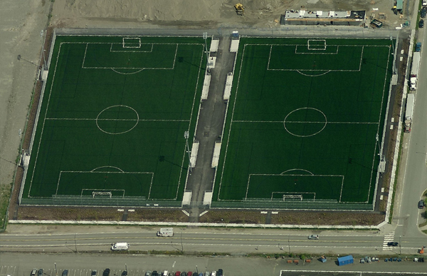
This year’s GVISAA ultimate tournament will be held at Trillium Park, located at National Avenue and Thorton Street in Vancouver. These fields are artificial turf which means the tournament will run rain or shine. Fields 1-4 have been booked from 8:30 am to 3:30 pm.
Free Parking
Disc Central
Bathrooms
4
3
2
1

Captains/Coaches Meeting
There will be a short coaches/captains meeting at 8:30 am to clarify tournament rules.

Games
Due to uneven numbers, the duration of games and goals needed to win a game are different for each pool. This is common practice in ultimate.

Pool A: games are 60 minutes or first team to 11, 1 time out per half
Pool B: games are 75 minutes or first team to 15, 1 time out per half

Rules
USA Ultimate rules to be followed. Key rules and exceptions listed below. http://www.usaultimate.org/resources/officiating/rules/11th_edition_rules.aspx

Gender ratios
The on-field gender ratio is 4 boys to 3 girls, or 3 boys to 4 girls. Pulling team must match gender ratio of receiving team. Receiving team will inform pulling team if they play 4 girls and 3 boys. Following “Spirit of the Game” teams are encouraged to give consideration to teams that may have a limited numbers when set up ratios on the field.

Timeouts
• 1 timeout per half, half is reached when one team reaches 8 points in pool A and 7 points in pool B.
• Timeouts limited to 2 minutes.
• No timeouts during double game point.

Tiebreaker
- results of “head to head” competition.
- fewest points or goals allowed over the course of the tournament.
- best point or goal differential over the course of the tournament (+/-).
- most points or goals scored over the course of the tournament.
- flip of a coin.

Spirit of the Game
The most important part of ultimate is “Spirit of the Game”. This is used to describe the respect that every player in the game has for the rules and their fellow players. There are NO referees in ultimate, players are expected to officiate themselves. Implicit in Ultimate is the understanding that players will conduct themselves with respect for the rules, sportsmanship and fair play. Spirit of the Game does not exclude being competitive, in fact it encourages players to compete at their highest level will still maintaining a sense of sportsmanship.

Post Game Spirit Activities
Spirit game/cheer: Teams are encouraged to meet after a game and play a spirit game or a cheer.
Spirit Prizes: are given by your team to the other team after every game. This award is given to the player (male or female) that best exemplifies Spirit of the Game. Consider a chocolate bar, can of pop, banana, or funny item from the dollar store.

Awards Ceremony
There will be a short awards ceremony at the conclusion of the tournament. Trophies will be awarded to the 1st, 3rd and 5th place teams as well as a trophy to the Most Spirited team.

Other
Players should bring snacks, lunch, sports drinks and water to the tournament. There is a fountain onsite and a bathroom. The Change Room Codes are:
Women’s CR 3 & 2 at the same time then 5
Men's CR 2 & 5 at the same time then 3

Schools may bring a tent, but it cannot be set up on the field.

Good luck to all the participating teams!!

Kyle Nystad
Senior School Athletics Director
Stratford Hall

Pool A: GAMES TO 11 | Pool B: GAMES TO 15
SH  BCCA  King David  Traditional Learning Academy  West Coast Christian | Regent Christian  St. John’s  Carver Christian  Waldorf
Pool A
Time | Field 1 | Field 2 | Bye
9:00-10:00 | King David vs WCC | Stratford Hall vs TLA | BCCA
10:05 – 11:05 | BCCA vs TLA | Stratford Hall vs WCC | King David
11:10-12:10 | BCCA vs WCC | Stratford Hall vs King David | TLA
12:15-1:15 | KD vs TLA | SH vs BCCA | WCC
1:20-2:20 | KD vs BCCA | TLA vs WCC | Stratford Hall
Pool B
Time | Field 3 | Field 4
9:00-10:15 | Regent vs Carver | St. John’s vs Waldorf
10:25-11:40 | Regent vs Waldorf | St. John’s vs Carver
11:50-1:05 | Regent vs St. John’s | Carver vs Waldorf

Playoffs: Games to 13
Time | Field 1 | Field 2 | Field 3 | Field 4
2:30-3:30 | A3 vs B3 | A1 vs B1 | A2 vs B2 | A4 vs B4

