How to keep score in Table Tennis
The score begins at 0-0, and the server will serve first. Each player gets to serve for two points in a row, and then the other player has to serve. You are not allowed to give the serve away and choose to receive all the time, even if both players agree.
When serving, you must follow the rules for a legal serve, and hit the ball so that it touches your side of the table once, then bounces over or around the net, and then touches your opponent's side of the table. A serve that touches the net assembly (the net, net posts, and net clamps) on the way, but still touches your side first and then your opponent's side on the second bounce, is called a let serve (or just let) and must be replayed, with no change to the score. There is no limit on how many lets you can serve in a row.
If you are playing doubles, you must serve the ball diagonally so that it bounces first in the right hand half of your side of the table, goes over or around the net, and then bounces in the right hand half of your opponents' side of the table (their right hand side, not yours!).
Your opponent will then attempt to return the ball over or around the net so that it bounces first on your side of the table. If he cannot, you win the point. If he does, you must hit the ball over or around the net so that it bounces first on his side of the table. If you cannot, he wins the point. Play continues in this manner until either you or your opponent cannot return the ball legally, in which case the other player wins the point.
In doubles, each of the players take turns to hit the ball. The server hits the ball first, then the receiver, then the server's partner, then the receiver's partner, and then the server again. If a player hits the ball when it is not his turn, his team loses the point.
When a point is won, that player or team adds one to their score. A game is won by being the first player or team to reach 11 points, with a lead of at least 2 points. If both players or teams reach 10, then the game is won by the first player or team to get two points ahead. Also, if a score of 10-all is reached, both players or teams will only serve 1 serve each until the game is won. The score is called out with the server's score first.
In the final possible game of a match, when the first player or team reaches 5, the players must change ends. If it is a doubles match, the players also change the order of receivers.

How to grip a ping pong paddle
1, Shakehand Grip
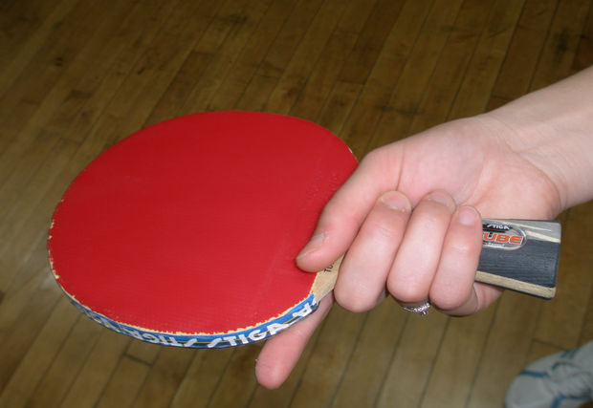
This grip is named the "Shakehand" grip because of the way the paddle is held. This grip is the most common and is a great start for beginning players. It gives the advantage of being able to perform backhands with ease. One disadvantage to this grip is that it has a wide crossover point between forehand and backhand, meaning that there is a large area where a player cannot hit easily with forehand or backhand without changing their position.

-The handle is gripped the same way a hand is gripped while shaking hands.
-The thumb, pinky, middle and ring fingers are wrapped around the handle while the pointer finger is laid out near the base of the rubber.
-The handle should be gripped firmly.

2, Penhold Grip
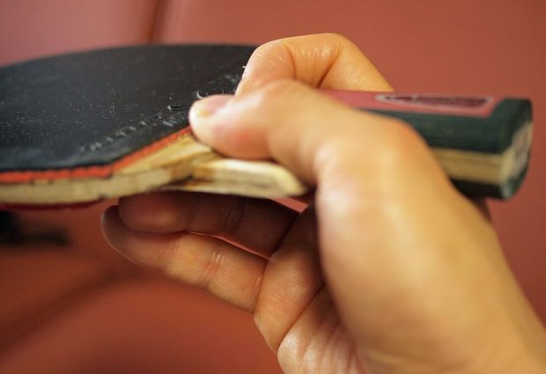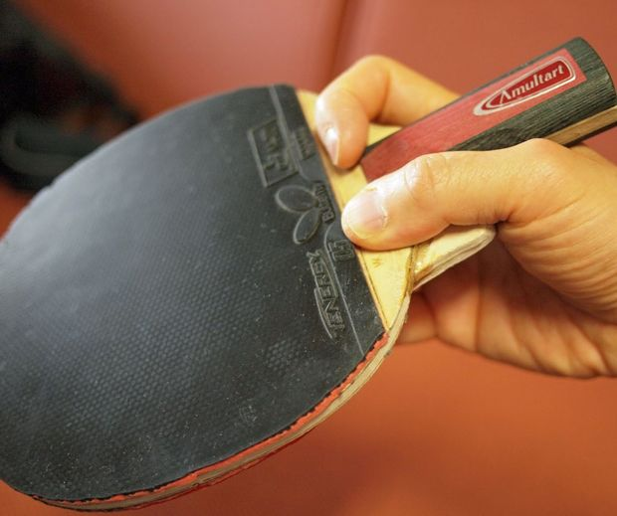
This grip is named the "Penhold" grip because of the way the paddle is held. This grip is far less popular than the previous grip; the majority of penholders are Asian and about 1/3 of Asian ping pong players use this grip. It gives the advantage of being able to cover a wide area with backhand and forehand while in a stationary position. One disadvantage to this grip is that backhands are hard to perform. Even when mastered, backhands with a penhold grip are less powerful than backhands with a shakehand grip. Overall, this grip is harder to master.

-The handle is gripped similarly to holding a pen.
-Wrap the thumb and forefinger around the handle near the start of the handle.
-The other fingers can be laid out across the back to create a firmer grip. Or it can be kept together, so the fingers won't be in the way when using backhand.

The history of Table Tennis
Around 1898 the English sports company John Jaques & Son were manufacturing the first table tennis sets and popularising the game.

They used rackets (bats / paddles) with velum stretched over an outer casing (similar to a small drum) attached to a handle. This gave rise to the name Ping Pong which was derived from the sound that was made by different sized rackets (bats / paddles) striking a ball.

And as the popularity of the game spread in Europe, two rival organisations were set up in England with the "Table Tennis Association" and the "Ping Pong Association" formed within days of each other in 1901.

But soon after this time in the history of table tennis it's thought that the game fell out of favour. But by the 1920s it was back in fashion, particularly in Europe.

Ping Pong v Table Tennis
Well, as we saw earlier, when the game started in the 1890s, various patented or trademarked names were being used by different manufacturers.

So when the English sports company John Jaques & Son became the market leader in the 1920s with their version of the game called "Ping Pong", they decided that they would only allow their trademarked name to be used if their brand of equipment was specified exclusively.

As more and more ping pong tournaments were now being organised, they also threatened legal action against anybody who used their proprietary trademarked name of Ping Pong without specifying the use of their equipment.

Therefore an alternative name was required for this burgeoning international sport and the name Table Tennis was chosen. So, since that time, and particularly since the establishment of the International Table Tennis Federation (ITTF) in 1926, the modern game has been known as table tennis.
VIDEO:(http://www.allabouttabletennis.com/history-of-table-tennis.html) (History)

Table Tennis and Health
Table tennis is good for your health - it's great for getting up a sweat and getting the heart rate up. Played at the higher levels, it's one of the fastest sports around. But you don't have to be a pro to get a good workout. Just a couple of hours a week hitting that little white ball around can do wonders for your fitness.

Keeps You Mentally Sharp. As you get older, ping-pong is good for the brain. There is an awful lot of thinking, planning, and strategising going on out there on the court, all of which helps keep the old grey matter active!

Ward off Alzheimer's & for assist in the treatment of Dementia!
Increases concentration and alertness
Stimulates brain function
Develops tactical thinking skills
Develops hand / eye coordination
Provides aerobic exercise
Provides social and recreational interaction

VIDEO (health): http://www.table-tennis-tables.co.uk/shop/customer-service/health-benefits.html

Bibliography
“http://tabletennis.about.com/od/howtokeepscore/a/keepscore.htm” How to keep score in Table Tennis (Feb 6, 2015)

“http://www.instructables.com/id/How-to-Grip-a-Ping-Pong-Paddle/all/?lang=zh”
How to grip ping pong paddle (Feb 6, 2015)
“http://www.allabouttabletennis.com/history-of-table-tennis.html”
The history of Table Tennis (Feb 11, 2015)
“http://tabletennis.about.com/od/beginnersguide/tp/reasonstoplay.htm”
Table Tennis and Health (Feb 11, 2015)
“http://www.table-tennis-tables.co.uk/shop/customer-service/health-benefits.html”
Table Tennis and Health (Feb 11, 2015)
Backhand topspin
Firstly, get our feet wide apart and fairly square to where you want the ball to go.
Secondly, start with your paddle down between hip high and knee high.
Thirdly, come forward, we brush the ball on contact and finish with your paddle turned all the way over.

Forehand topspin
Firstly, have your feet nice and wide apart, you can be quite square on to the table or turn a little bit more towards your forehand side.
Secondly, your start position need to start with your paddle fairly flat and to be down and around knee high or between your hip and knee.
Thirdly, make a brushing contact and then finish with your paddle up nice and high above your head with two 90 degree angles

Doubles
When playing doubles, each player still has two serves and the service still alternates every two points between sides, but it also alternates between players on the same team.
At the end of every two points, the receiving player becomes the server, and the partner of the serving player becomes the receiver.
The service itself is exactly the same as in singles except that, rather than the ball bouncing anywhere on the table, it must bounce only on the right half portion of the table for both the server and the receiver.
The receiver returns it, then the server's partner must hit it next followed by the receiver's partner and so on.
Play must continue in this sequence throughout the rally and if a player hits it out of turn he loses the point.

A player loses a point if he:
Fails to make a good serve (eg. throwing the ball in the air and failing to hit the ball or failing to hit it onto his opponent's side of the table)
Allows the ball to bounce twice on his side of the table
Does not hit the ball after it has bounced on his side of the table
Does not hit the ball onto his opponent's side of the table
Hits the ball before it has bounced (i.e. volleying the ball) unless it's obviously not going to bounce on his side of the table
Hits the ball twice in succession (i.e. a double hit)
Puts his non-playing hand on the table or net or moves the table
Obstructs the ball with any part of his body or clothing (unless it's obviously not going to bounce on his side of the table)
Hits the ball out of turn when playing doubles

A Game
As we saw earlier, when one player has scored 11 points (or when one player has a two point lead if the score previously reached 10-10), he wins the game.
The players then swop ends and the next game begins with the player who served second in the previous game.

A Match: The rules of table tennis state that a match is the best of any odd number of games - usually 3, 5 or 7 games.
Bibliography
“https://www.youtube.com/user/pingskills” skills of table tennis Feb 17, 2015
“http://www.allabouttabletennis.com/rules-of-table-tennis.html” rules of Doubles Feb 18, 2015

