Ping Pong
History: “Table tennis”, more commonly known as “Ping Pong” from the sound created when the game ball hits the paddles, is a game that originated in England, during the 1880s, where it was played among the upper-class as an after-dinner parlour game. The first form of Ping Pong was played with a row of books stood up along the centre of the table as a net, two more books served as rackets and were used to continuously hit a golf ball from one end of the table to the other. The popularity of the game eventually led game manufacturers to sell Ping Pong equipment commercially. In 1901, a British enthusiast of table tennis named James W. Gibb discovered novelty celluloid balls on a trip to the US and found them to be ideal for the game. These celluloid balls are the common ping pong balls that are used in the game today, and soon after the founding of the celluloid balls, E.C. Goode invented the modern version of the racket by fixing a sheet of pimpled rubber to the wooden blade. Table tennis was growing in popularity by the year 1901 to the extent that tournaments were being organized, books being written on the subject, and an unofficial world championship was held in 1902. In 1921, the Table Tennis Association was founded in Britain, and the first world championship was hosted in London in 1926.
Fun fact: During the early 1900s, Ping Pong was banned in Russia because the rulers at the time believed that playing the game had an adverse effect on players’ eyesight.
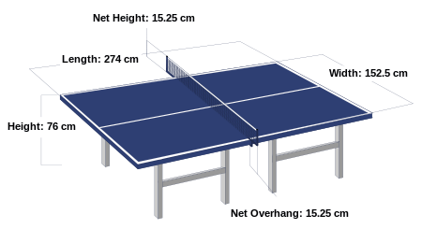
The official dimensions of the ping pong table are 274 by 152.5 cm, with a net height of 15.25 cm, and a distance of 76cm from the table surface to the floor.
Play: The first serve is decided by lot, normally a coin toss. The winner of the lot chooses whether to serve or receive, or chooses what side of the table to use. In game play, the player serving the ball commences the play. The server first stands with the ball held on the open palm of the hand that isn’t carrying the paddle, called the freehand, and tosses the ball upwards without spin. The server then strikes the ball with the paddle on the ball’s descent so that it first touches his court and then directly touches the receiver’s court without touching the net. The server cannot use his body or clothing to obstruct sight of the ball; the opponent must have a clear view of the ball at all times. The receiver of the serve has to return by hitting the ball back before it bounces a second time on his side of the table so that the ball passes the net and touches the opponent’s court. If a player fails to return the ball, returns the ball without it touching his opponent’s side of the court, or allows the ball to bounce twice in a row on his court, the opponent is awarded a point.

Let: A let is a rally of which the result is not scored, and is called in the following circumstances:
-The ball touches the net in service, or the receiver strikes the ball before it touches his side of the court in service, which is known as obstruction
-When the person on the receiving side is not ready and the serve is delivered
-Play is interrupted

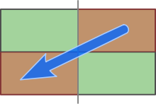
Doubles Game: In addition to games between individual players, pairs may also play Ping Pong. A line painted along the long axis of the table to create doubles courts bisects the table. This line's only purpose is to facilitate the doubles service rule, which is that service must originate from the right hand "box" in such a way that the first bounce of the serve bounces once in said right hand box and then must bounce at least once in the opponent side's right hand box (far left box for server), or the receiving pair score a point.
Players must also alternate hitting the ball, failure to do so will result in the opposing team scoring a point. At each change of service, the previous receiver shall become the server and the partner of the previous receiver becomes the receiver.

Grips
Penhold: The penhold grip is so-named because one grips the racket similarly to the way one holds a writing instrument.
Shakehand: The shakehand (or shakehands) grip is so-named because the racket is grasped as if one is performing a handshake.

