Swimming

Health Benefits:
Health benefits to swimming are burning off many calories; it builds your muscular endurance and strength and improves cardiovascular fitness. What’s great about swimming is that it’s easy on your joints, it’s cool and refreshing on hot days, and you can do it throughout your lifetime, even when you’re older. In a study with middle-aged men and women who took swimming training for 12 weeks, oxygen consumption improved by 10% and stroke volume, which is how much blood is pumped into your heart each beat (heart strength), improved by 18%. Depending on how you swim and how buoyant you are you could burn about 500-650 calories in an hour. Original research showed that swimming, mindless of the stroke, burns 11% fewer calories than running and 3% fewer calories than biking. It is possible to burn off as many calories swimming than running, depending on how hard you exercise. In a study with men who took part in an 8-week swim program, the men had a 23.8% increase in their triceps muscles.

History:
The beginnings of swimming started thousands of years ago, but competitive swimming became known and popular in the 1800s. It was first included in the 1896 Olympic Games in Athens, Greece. In the 1904 Olympics in St. Louis, USA the freestyle, backstroke, breaststroke and relay races were introduced. By the 20th century indoor pools were being made in towns with populations of 20,000 people or more. Swimming clubs also became popular. Women started participating in the Olympic swimming events in Stockholm, Sweden.

Safety Rules for Swimming:
    - Do not dive in to the pool to save drowning people, unless you are a professional or skilled swimmer or safety guard. Use a life-saving floatation device to save someone.
- Do not dive in to the shallow end.
- Read the signs.
- Do not run around in the pool, especially around the edges of the pool.
- Do not go beyond your abilities.
- Never swim alone.
- No horseplay in the pool.
- Be careful getting in and out of the pool. If there are handrails, use them.
- Avoid opening eyes underwater without goggles.

Swimming Strokes:
Freestyle-Front crawl (also known as the Australian crawl or the American crawl)
You kick your legs in an alternating order. Bend your knees slightly. Relax your feet and ankles, so that they’re almost floppy. Emphasize down-kick for momentum. Also called the flutter kick.
Your arms should move in an alternating windmill motion. Pull the water with each arm in the water with equal strength so that you swim straight. Cup your hands and keep your wrists and hands relaxed.
As you raise one arm to stroke and your shoulder rises, turn your head to take a breath out of the water. Only lift your head out of the water to breathe, because if you lift it too much it will slow you down. Take as many breaths as needed. Turn your head to the other side with the opposite arm stroke.

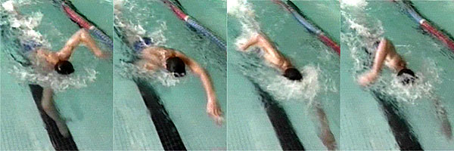
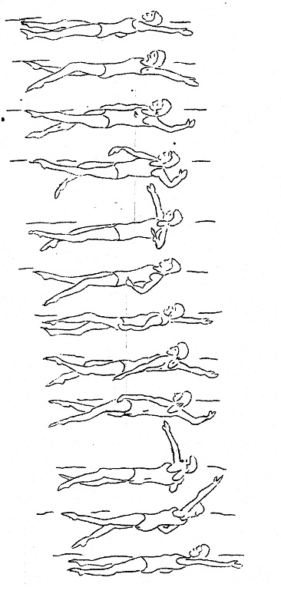
Backstroke-
You kick the same as you kick for the front crawl, which is the flutter kick.
Move your arms in alternating windmill motion, as they rotate and pass your side of the face. Cup your hands, and make sure your thumbs are leaving the water first. Move your arms in equal strength, to make sure you don’t go offside.
Keep your head back and direct your eyes toward the ceiling. Since your head is always out of the water, it is easier to take care of breathing than other strokes.

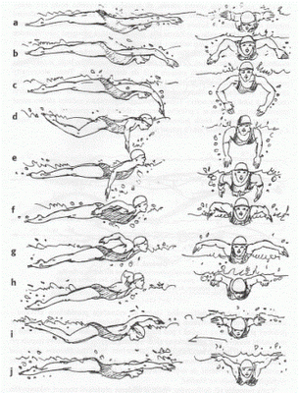
Butterfly – It’s a difficult and challenging stroke, since it requires perfect timing and good deal of strength.
Bend your knees slightly, and keep them together. Your legs need to move together, performing the dolphin kick (like a mermaid). Whip your feet downward, and there should be two kicks for every arm stroke.
Cup your hands, and pull through the water. The arms should move in same motion. Swing your arms forward, above the water, in a sweeping motion.
Breathe at the end of the arm stroke.

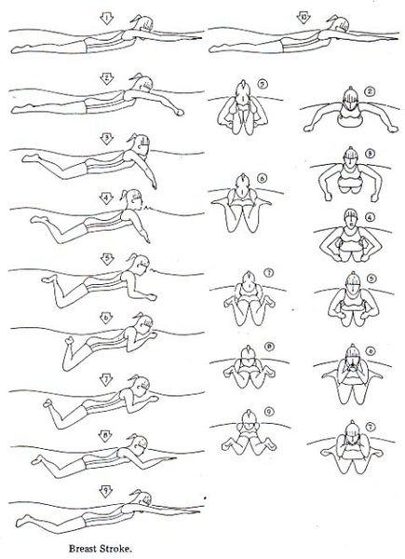
Breaststroke- It requires perfect timing and definitely not an easy stroke for the beginners. With the breaststroke, you could be disqualified from a competition if you miss a single stroke. This stroke takes form that causes your body to bob up and down as you travel through the water.
Bring your knees to your chest; make sure your legs are straight and facing backwards. Snap your legs together to push the water and move forward (frog kick).
Keep your hands cupped, start with placing your arms over head, pull on the water and bring your arms toward the chest. Return your arms to the starting position.
Breathe every time you stroke your arms.
Basically, your arms pull, you breathe, and you kick while your arms alternate with the kick; as you glide.

Work Cited

Information:

<http://livelovelaugh-lace1013.blogspot.ca/2007/11/power-of-butterfly.html>

<http://www.medicinenet.com/swimming/article.htm>

<http://en.wikipedia.org/wiki/Front_crawl>

<http://the17thman.onsugar.com/tag/Swim-Training-2006?page=15>

Images:

<http://www.google.ca/imgres?hl=ko&sa=X&biw=1249&bih=615&tbm=isch&prmd=imvns&tbnid=Hzzg6I4nUwAj8M:&imgrefurl=http://research.fuseink.com/p698p72paypt6/difference-between-swimming-vs-running&docid=bQcDlj74Et9DtM&imgurl=http://research.fuseink.com/artifactimg/MTMyMDIxNTgzMzM0NjdfMQ.jpg&w=600&h=200&ei=ag1uUJyRBsX5igLAsYCACA&zoom=1&iact=hc&vpx=52&vpy=286&dur=112&hovh=129&hovw=389&tx=206&ty=58&sig=106733621962094724820&page=1&tbnh=59&tbnw=176&start=0&ndsp=18&ved=1t:429,r:6,s:0,i:87>

<http://www.google.ca/imgres?start=339&hl=ko&biw=1249&bih=615&tbm=isch&tbnid=Wge7o22mYXTsdM:&imgrefurl=http://pizxebe.wordpress.com/everything-experienced/swimming/backstroke/&docid=d_DewyIjSi3APM&imgurl=http://pizxebe.files.wordpress.com/2011/05/backstroke.jpg&w=366&h=778&ei=Vw5uULi0GuSKjALqoID4Bw&zoom=1&iact=hc&vpx=109&vpy=6&dur=104&hovh=328&hovw=154&tx=78&ty=164&sig=106733621962094724820&page=15&tbnh=135&tbnw=62&ndsp=27&ved=1t:429,r:20,s:339,i:226>

