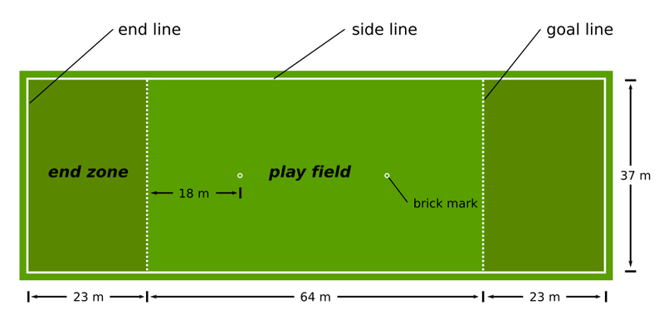

Ultimate Frisbee History & Rules
Ultimate Frisbee was created in 1968 by a group of staff members and student council representatives in Maplewood. They started this new sport as an activity for high school students in their spare time. Its first name was “Frisbee Football” which was later changed to Ultimate Frisbee which is the sport we know today. Ultimate Frisbee has grown drastically over the past years and is now played in 42 countries by around 100 000 people.
As Ultimate Frisbee has developed so have the rules. These are some of the important ones.
- To start the game one team throws the Frisbee to the opposite team who stands on their base line this is called a “pull”
- The disc may be moved in any direction by completing a pass to a teammate. After catching a pass, a player is required to come to a complete stop as quickly as possible, and then can only move their non-pivot foot.
- The players only have ten seconds to pass the Frisbee (you can count in stalls)
- a point is scored when a player catches a disk in the opposing teams end zone
- if your team drops the disk then the opposing team has possession
- if a player hits the arm of the person with the disk then it’s considered a violation
- if the disk goes out of bounds then you bring it to the edge line where it went out and the opposing team throws it in

Ultimate Frisbee Outline Shannon & Cecilia
Supplies
- Frisbees
- Cones
- Whistles
- Clothes to fit the weather
- Pinies
Safety
- Pay attention at all times so that you won’t get hit in the head by a Frisbee
- Wear proper footwear such as runners
- Have a positive attitude
Learning Outcome
- Students will be able to properly throw a Frisbee
- Students will understand the basic rules of Ultimate Frisbee
- Students would have had an enjoyable time and exercise
Game Plan
Day 1(passing)
- Warm-up
  - One lap around the field
- Drills
  - Pass Frisbee between a partner (different throws)
  - Passing rectangle
  - “Pulling” and catching
- Game
  - ++Jackpot
Day 2(defense)
- Warm-up
  - Freeze tag
- Drills
  - Pass with a partner
  - Group piggy in the middle
  - 3 people piggy in the middle
- Game
  - Ultimate Frisbee
Day 3(playing drills)
- Warm-up
  - Jumping jacks
- Drills
  - Pass with a partner down the field
  - fetch in partners
  - passing Frisbee, pivoting relay race(pfprr)
- Game
  - Ultimate Frisbee
Day 4 (game day)
- Warm up
  - Pass the Frisbee in a circle
- Games
  - Mini games
  - Big game
Day 5(test)
- Written test
- Practical
  - Passing- with a partner in a specific zone

Bibliography
Zagoria, Adam. “Ultimate History” http://www.whatisultimate.com/history/history_game1_en.html. 12 Nov.2012
“Ultimate Frisbee Rules” http://www.ultimatefrisbeerules.org/. 12 Nov. 2012

