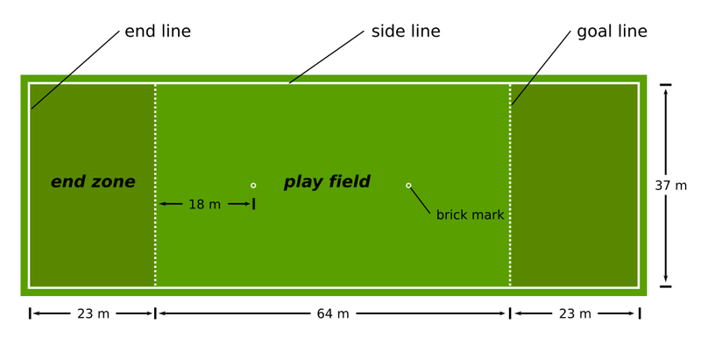

Ultimate History & Rules
Ultimate Frisbee was created in 1968 by a group of staff members and student council representatives in Maplewood. They started this new sport as an activity for high school students in their spare time. Its first name was “Frisbee Football” which was later changed to Ultimate Frisbee which is the sport we know today. Ultimate Frisbee has grown drastically over the past years and is now played in 42 countries by around 100 000 people.
As Ultimate Frisbee has developed so have the rules. These are some of the important ones.
- To start the game one team throws the Frisbee to the opposite team who stands on their base line this is called a “pull”
- The disc may be moved in any direction by completing a pass to a teammate. After catching a pass, a player is required to come to a complete stop as quickly as possible, and then can only move their non-pivot foot.
- The players only have ten seconds to pass the Frisbee (you can count in stalls)
- a point is scored when a player catches a disk in the opposing teams end zone
- if your team drops the disk then the opposing team has possession
- if a player hits the arm of the person with the disk then it’s considered a violation
- if the disk goes out of bounds then you bring it to the edge line where it went out and the opposing team throws it in

